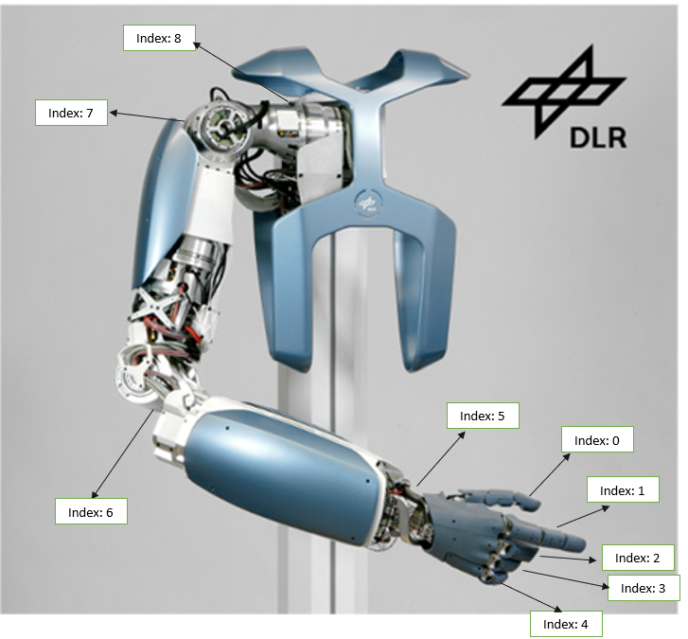

Motors Ranges

|  |  |  |
| --- | --- | --- |
| Index | Min | Max |
| 0 | 150 | 10 |
| 1 | 150 | 10 |
| 2 | 150 | 10 |
| 3 | 150 | 10 |
| 4 | 150 | 10 |
| 5 | 10 | 160 |
| 6 | 10 | 180 |
| 7 | 180 | 10 |
| 8 |  |  |

Code